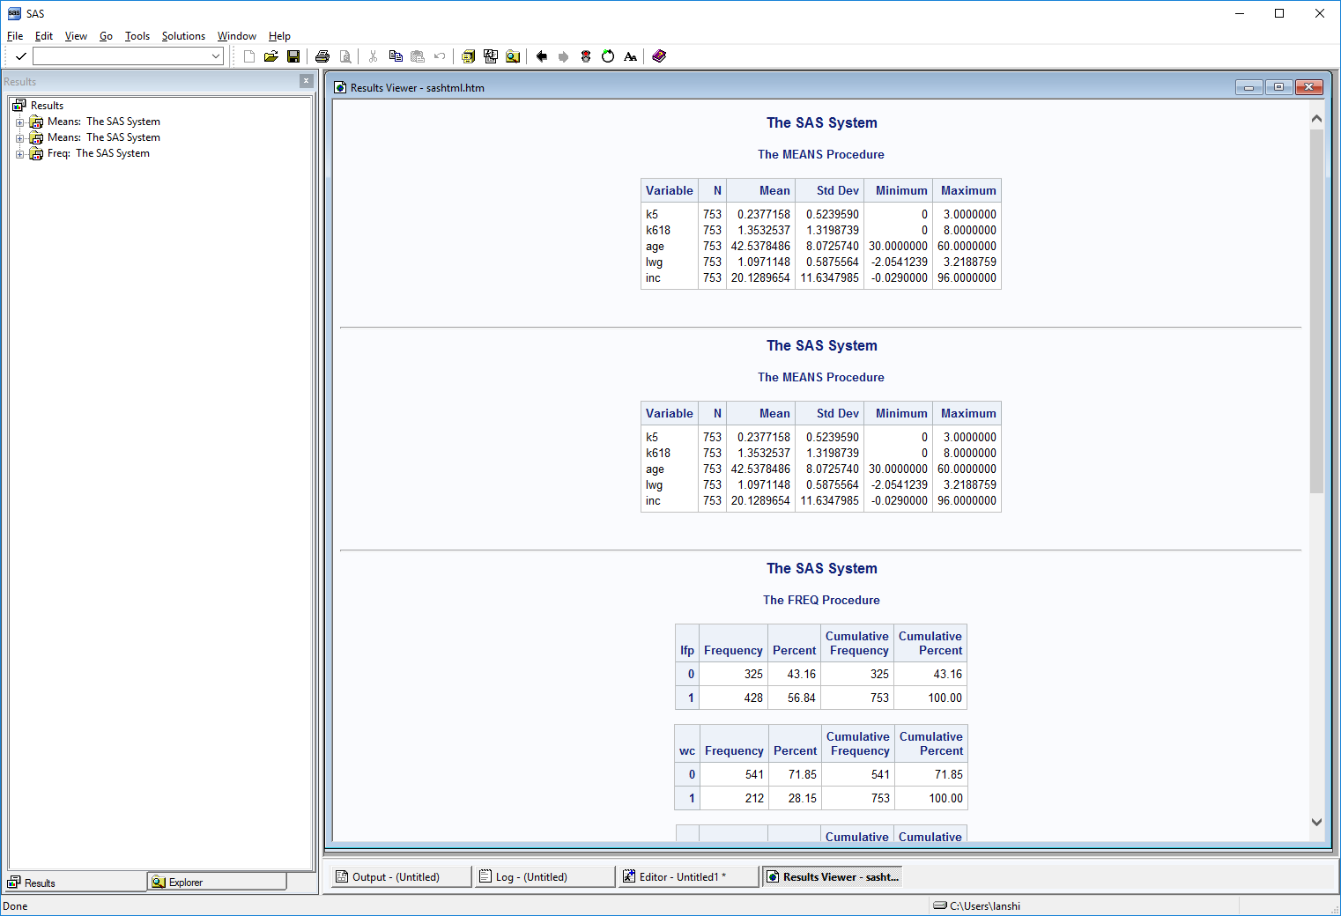

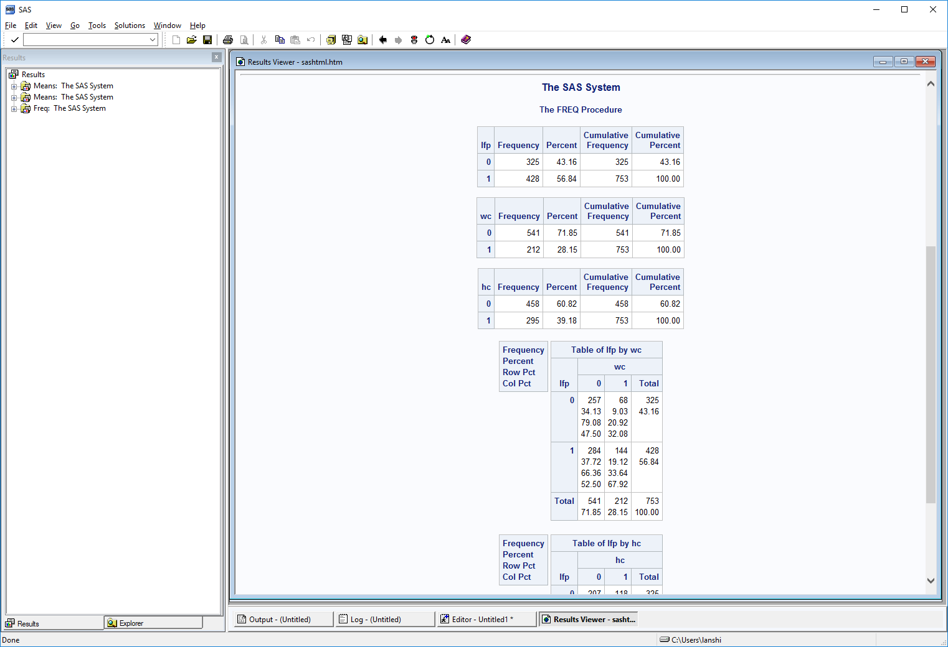

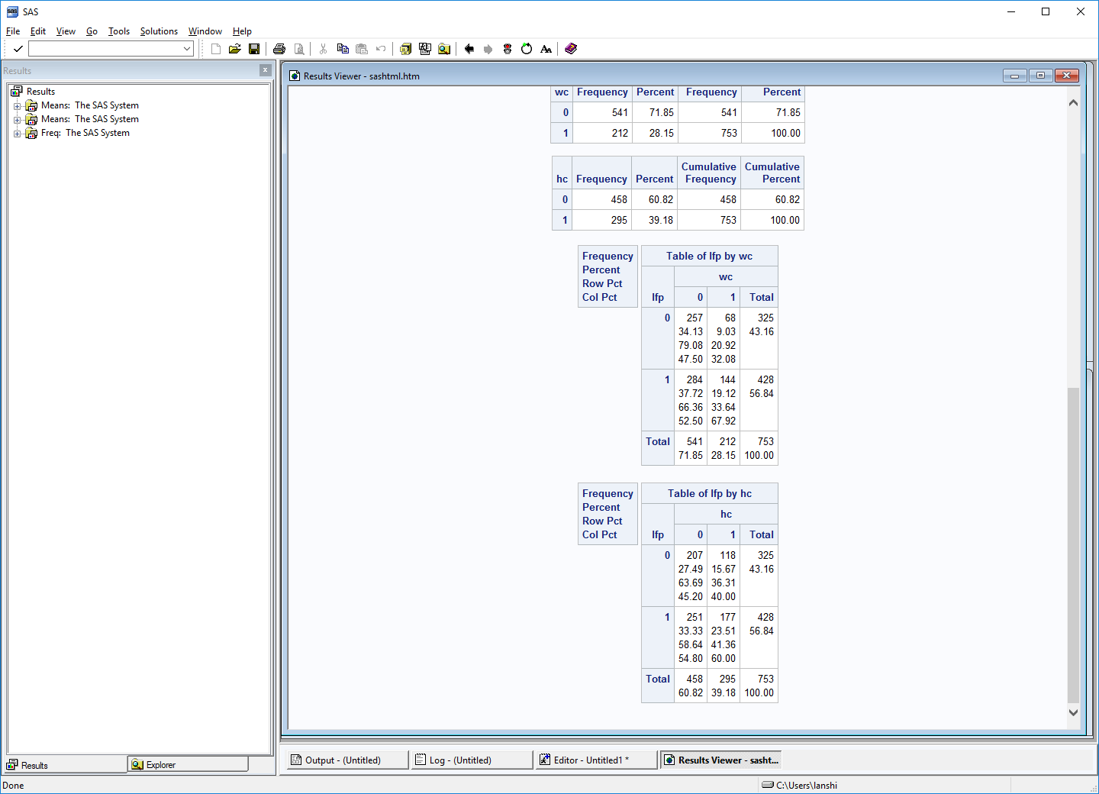

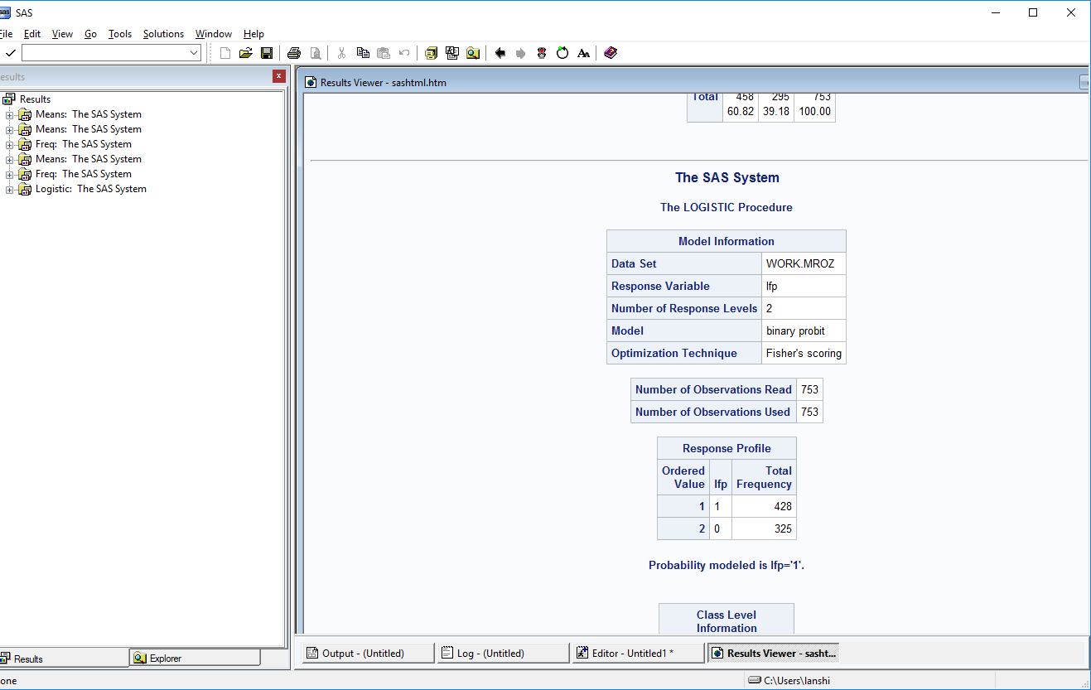



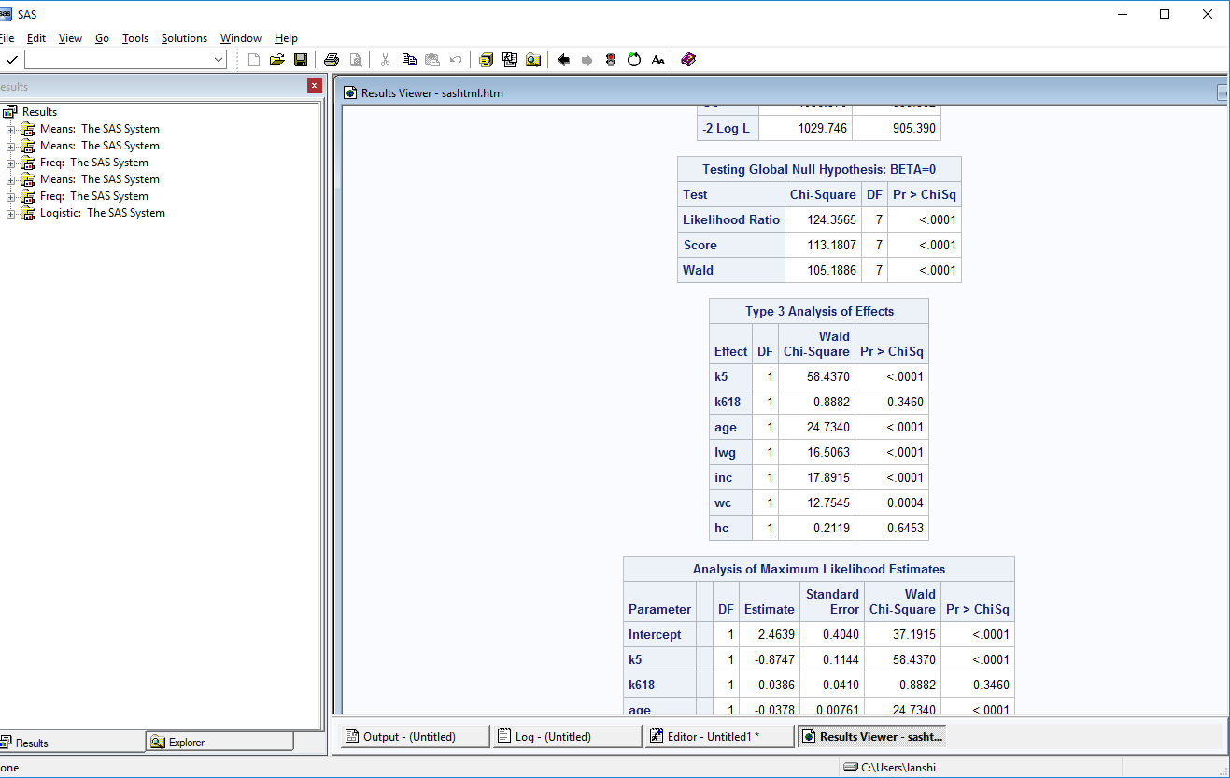

The result of the Global Null Hypothesis (by Likelihood Ratio, Score and Wald test) indicates that the model is statistically significant. 

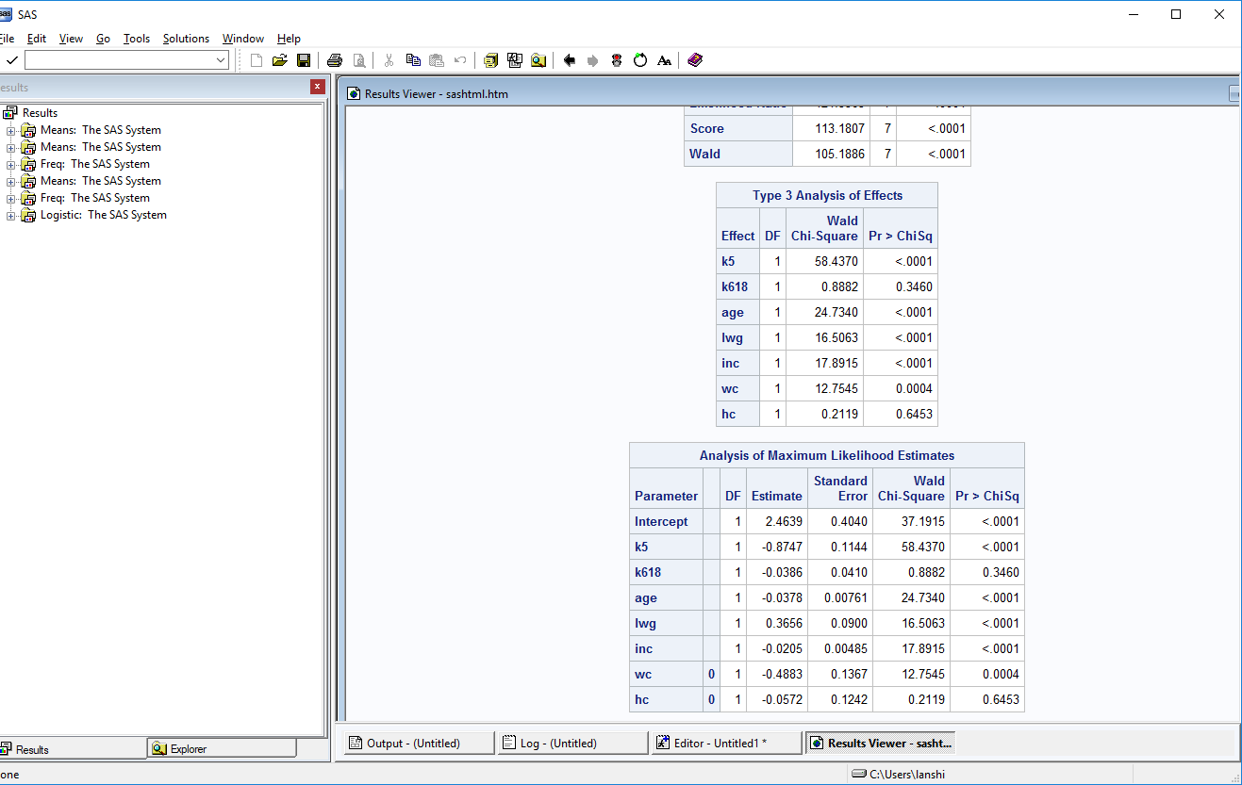

As for each variable in the model, it is shown by the above two tables that: variable **k618** and **hc** both have p-value greater than 0.05, thus under significant level alpha being 0.05, they are not statistically significant. The reason for **k618** might be that kids of 6-18 are much more independent than kids less than 6, and their mom could have time to work. Regarding **hc,** whether husband has attended college won’t really affect their wife’s decision on whether being in the labor force or not.

Interpretations:

(Definition of z-score: the probit regression coefficients give the change in the probit index, also called a z-score, for a one unit increase in the predictor variable.)

* **k5:** For each one more kid less than 6 years old, the z-score decreases by 0.8747.
* **k618**: For each one more kid of 6-18 years old, the z-score decreases by 0.0386.
* **age:** For one year increase in a woman’s age, the z-score decreases by 0.0378.
* **lwg:** For a one unit increase in log(wage), the z-score increases by 0.3656.
* **inc:** For a one unit increase in (family income – wage*hours)/1000, the z-score decreases by 0.0205.
* **wc:** Wife having attended college would increases the z-score by 0.4883.
* **hc:** Husband having attended college would increases the z-score by 0.0572.

**k5** has the largest impact:

